PoMLabApp

The latest version of the project is available in my github.

<https://github.com/masahiroshinya/PoMLab>

# Installation

The PoMLab has not registered for the Google Play Store. It means you need to allow apps from unknown sources. Many guide articles are available on the web. For example,

<https://www.cnet.com/how-to/how-to-install-apps-outside-of-google-play/>

If you need more, search for “how to install apk” or “android allow apps from unknown sources”.

# PoMLab task

The task is to hit a yellow cursor to a target cursor (cyan). A typical instruction for subjects is as follows:

*You can control this yellow cursor by tilting the device (by showing the app working). At first, please keep the yellow cursor at the center of this white circle. Then, as a cyan circle will appear as a target, please hit it by tilting the device. The target will disappear in 2 seconds if you miss it. So please rapidly hit the target with a straight path. Please continue this for ** time until the session ends.*

For details, please kindly read our article.

Development of a Portable Motor Learning Laboratory (PoMLab)

Ken Takiyama , Masahiro Shinya

<http://journals.plos.org/plosone/article?id=10.1371/journal.pone.0157588>

# Experimental parameters

Experimental parameters are set by using two csv files: config.csv and protocol.csv. For the first time after the installation, default config.csv with typical values and some protocols are prepared. These files are located in *PersistentDataPath* (for detail, search for “unity Application.persistentDataPath”) in the device.

For my Nexus 9, this is

“/storage/emulated/0/Android/data/com.PoMLabProject.PoMLabApp/files”.

You can modify, replace and add config and protocol files at any time. This can be done either by using a file-exploring app or by connecting the device to a computer with usb cable.

## Config file

All the parameters needed for the PoMLab experiments are specified in the config.csv. Please see “config template en.xlsx”, modify it and save it as csv file. These values are used as default values. If some values are specified in protocol files, these will be overwritten.





## Protocol file

For parameters that you may want to vary from trial to trial (for example, target location & visuo-motor rotation) should be specified in protocol file.

This is an example of protocol for investigating motor learning for gradual visuo-motor rotation.



# Transformation from input from device to position of the cursor

## Orientation of the device

Orientation is fixed as portrait.

x

y

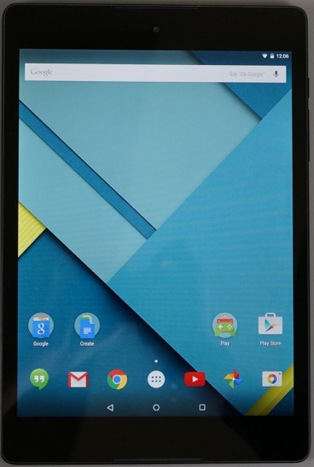

Main camera is located at [0, 0, -5], directed to [0, 0, 0] in the game space.

The projection style is set to orthographic.

## Tilt angle of the device

Tilt angle is calculated by using linear acceleration of the device.

**** we do not use angular velocity data from gyroscope nor Kalman filtering

$$TiltAngle=f\left(Acceleration\right)$$

 ****

or

$$\left[\begin{matrix}tiltX \\ tiltY \\ 0\end{matrix}\right]=\left[\begin{matrix}\sin^{-1}\left(AccX\right) \\ \sin^{-1}\left(AccY\right) \\ 0\end{matrix}\right]$$

## Tilt to cursor position transformation

Tilt of the device is transformed into cursor position

$$CursorPosition=R\left(θ\right)×G×\left(TiltAngle-Offset\right)$$

or

$$\left[\begin{matrix}x \\ y \\ z\end{matrix}\right]=\left[\begin{matrix}\cos{θ} & -\sin{θ} & 0 \\ \sin{θ} & \cos{θ} & 0 \\ 0 & 0 & 1\end{matrix}\right]\left[\begin{matrix}gainX & 0 & 0 \\ 0 & gainY & 0 \\ 0 & 0 & 1\end{matrix}\right]\left(\left[\begin{matrix}AccX \\ AccY \\ 0\end{matrix}\right]-\left[\begin{matrix}OffsetX \\ OffsetY \\ 0\end{matrix}\right]\right)$$

where, R(θ) is a visuo-motor rotation angle, G is a gain, and offset is an offset parameter.

If gain is set to 1, cursor will be located at [0, 1] (top of the device) when the device is tilted by 90 deg.

Offset is set so that cursor was located at [0, 0] when participants sit in their natural posture.

Typical value is -30.

## Mirror reversal

Cursor position is mirror reversed if “Is Mirror Reversed” is set TRUE in config or protocol file. The axis of mirror reversal can be specified by using “Mirror Reversal Axis Direction”. If “Mirror Reversal Axis Direction” is set 90 deg, for example, cursor movement will be left-right mirror reversed (i.e., if you tilt the device rightward, then the cursor will move leftward).

## Cursor clamp

Cursor position is clamped to a specified direction if “Is Clamped” is set TRUE. In this case, the cursor movement was projected to the “Clamp Direction”. Typically, the “Clamp Direction” is the same as “Target Direction”, so that the cursor will directly move toward the target.

## Max radius

Lastly, the “Max Radius” let the cursor move within the radius. If this is set to 1, the cursor can move to the end of the screen.

# Data analyses

Very preliminary data analysis is implemented in the app. You can see it in “summary.csv”. This calculates angular deviation of the cursor at maximum cursor velocity. Importantly, this does not use any filtering or error handling. Again, this is VERY PRELIMINARY. It may be useful for rapid inspection of the measured data but you MUST reanalyze the data offline.

The measured data is located in subfolders in *PersistentDataPath* (for detail, search for “unity Application.persistentDataPath”) in the device.

For my Nexus 9, for example, the data folder is

“/storage/emulated/0/Android/data/com.PoMLabProject.PoMLabApp/files/Data/”.

And in the data folder, the PoMLab creates subfolders for each experimental session with name: NAME_PROTOCOL_DATE.

NAME: subject name you entered in the app title.

PROTOCOL: the protocol file name

DATE: time stamp of the experiment (e.g., 20169030_145506)

To retrieve the acceleration data, you can

1. Connect the device to your computer with USB cable

2. Move the files to cloud service like dropbox by using file-exploring app

For details of offline data analyses, please kindly read our paper and other motor learning articles.

# References

## Peer-reviewed journals

Development of a Portable Motor Learning Laboratory (PoMLab)

Takiyama K., Shinya M.

<http://journals.plos.org/plosone/article?id=10.1371/journal.pone.0157588>

## Conference papers

A portable motor learning laboratory (PoMLab)

Shinya M., Takiyama K.

## Use cases

The University of Tokyo: class (Sports Sciences)